OrderLens
SAP & Snowflake Enabled Sales Operations Intelligence Architecture

Design & Architecture Document
Author | Yaswanth Kumar Reddy Etur
Reviewed By | <To be confirmed>
Approved By | <To be confirmed>
Distribution List | <Project stakeholders>
Document Creation Date | March 2026
Version | V1.0

Version History
Version | Date | Addition / Modification | Prepared By | Revised By
V1 | Mar 2026 | Initial Document Creation | Yaswanth Kumar Reddy Etur

Document Reference Number | Physical File Name
 | OrderLens_Design_Architecture_v1.0.docx

Important Notice
This YASH TECHNOLOGIES document has restricted circulation. No part of this document may be reproduced, stored in a retrieval system, or transmitted in any form or by any means — recording, photocopying, electronic & mechanical — without prior written permission of YASH TECHNOLOGIES (India) Private Limited.

Table of Contents
1. Objective
2. Current State Architecture
3. Refresh & Orchestration Strategy
4. Future State Architecture
5. High-Level Architecture Diagram
6. Data Pipeline Source / Target Details
7. Data Architecture & Processing Layers
7.1 Bronze Layer — SAP_STG (SAP Source-Aligned)
7.2 Silver Layer — RAW_VAULT (Data Vault 2.0)
7.2.1 Hub Tables
7.2.2 Link Tables
7.2.3 Satellite Tables
7.3 Gold Layer — INFORMATION_MART (Sales Analytics Mart)
8. Dealer Health & Scorecard
9. Dashboard Architecture (Streamlit)
10. Cortex / AI Integration
11. Security & Access Control
12. Error Handling & Recovery
13. Logging & Monitoring
14. Testing Strategy
15. Deployment Strategy
16. Data Retention Policy
17. Key KPIs Implemented

1. Objective
This document defines the architecture, design principles, and implementation strategy for OrderLens — an end-to-end Sales Operations intelligence and order analytics solution built on Snowflake, powered by SAP ERP sales data and surfaced through a Streamlit dashboard.

The solution consolidates sales order, customer, product, configuration, BOM, and demand data from SAP ERP into Snowflake using a structured Data Vault 2.0 modelling approach and exposes lifecycle KPIs through a self-service Streamlit dashboard with optional AI-assisted insights.

The platform enables:
- End-to-end Sales Order visibility across products, configurations, customers, dealers, and regions
- Standardized KPI framework covering Order History, Dealer Performance, Product Catalog & Pricing, Bill of Materials, and Demand Forecasting
- Scalable Data Vault 2.0 architecture (Hubs, Links, Satellites) for full historical traceability
- Automated incremental data loads from SAP ERP via Snowflake Dynamic Tables (90-day target lag)
- Dealer Health scoring with configurable KPI thresholds covering order volume, revenue, configuration mix, and fulfilment
- AI-assisted analytics using Snowflake Cortex (primary) or Azure OpenAI (secondary / optional)
- Self-service, interactive dashboard for sales operations, product management, and business users

Attribute | Details
Product Name | OrderLens
Platform | Snowflake + Streamlit
Source System | SAP ERP (SD / MM / PP / APO)
Snowflake Database | SALES_OPS_PLANNING
Data Model | Data Vault 2.0 (Hubs, Links, Satellites) → Snowflake Dynamic Tables
Frontend | Streamlit Web Dashboard

2. Current State Architecture
The OrderLens platform follows a Warehouse-Centric Enterprise Architecture implementing Data Vault 2.0 modelling within Snowflake. SAP ERP acts as the primary transactional source, with Snowflake Dynamic Tables managing automated transformation and materialization into structured vault layers.

Key Characteristics:
- SAP ERP (SD / MM / PP / APO) as transactional source system for sales, materials, BOM, configuration, and demand
- Snowflake Dynamic Tables for automated refresh, transformation, and sales lifecycle logic with configurable target lag
- Snowflake database SALES_OPS_PLANNING as centralized warehouse with Data Vault 2.0 structure
- Three-layer architecture: Bronze (SAP_STG) → Silver (RAW_VAULT) → Gold (INFORMATION_MART)
- Hub-Link-Satellite modelling for full historical traceability and auditability
- SCD Type 2 history tracking on all dimension entities via EFFECTIVE_DATE / EXPIRY_DATE / CURRENT_FLAG
- Streamlit as interactive sales operations intelligence dashboard consuming _VW views
- Role-based access control via Snowflake RBAC

Current Architecture — Logical Overview

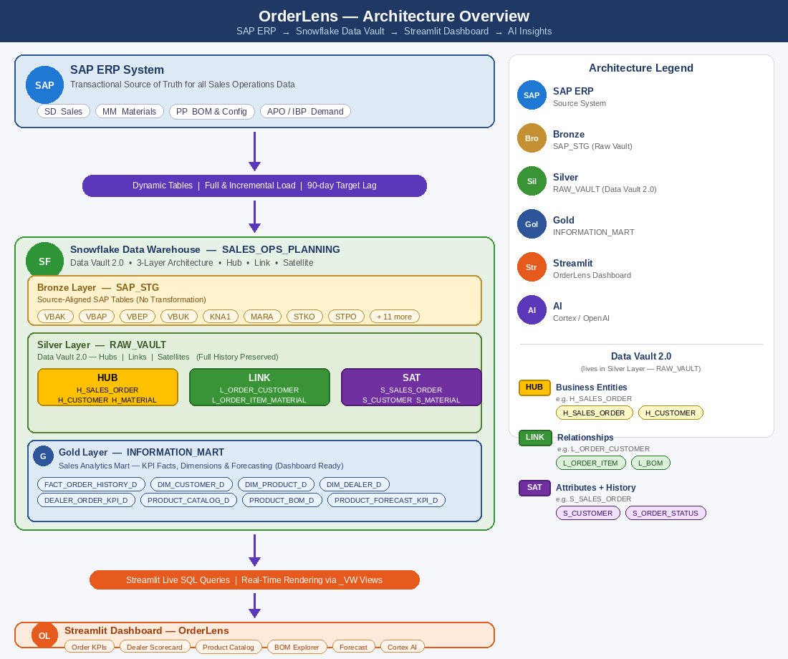

3. Refresh & Orchestration Strategy
Data integration is handled via Snowflake Dynamic Tables using automated target-lag refresh logic. The platform operates on a fully automated 90-day target lag framework with no manual intervention required for data loads and pipeline execution. Note: Deployment of new Snowflake objects or application changes to PROD still requires a change management ticket as described in Section 15.

Step | Activity | Description
1 | Data Extraction | SAP sales, customer, material, BOM, config, and demand data extracted to SAP_STG staging tables in SALES_OPS_PLANNING
2 | Dynamic Table Refresh | RAW_VAULT Dynamic Tables refresh Hubs, Links, and Satellites from SAP_STG on 90-day target lag using REFRESH_MODE = AUTO
3 | Raw Vault Load | SHA1 hashed business keys generated; satellite records loaded with SCD2 LOAD_DT / END_DT / HASHDIFF tracking
4 | Information Mart Build | INFORMATION_MART Dynamic Tables (DIM, FACT, KPI) refresh from RAW_VAULT joining Hubs, Links, and latest Satellites
5 | Dealer Score Compute | DEALER_ORDER_KPI_D aggregates order count, quantity, and revenue daily by dealer × product × configuration
6 | Forecast Blend | PRODUCT_FORECAST_KPI_D blends 3-month rolling sales history with SAP_DEMAND_PLAN using 60/40 weighted average for 6-month forward forecast
7 | Dashboard Query | Streamlit executes live SQL queries against INFORMATION_MART _VW views (SELECT * pass-through on Dynamic Tables)

Key Benefits:
- Automated, Snowflake-native Dynamic Table refresh with no manual orchestration required
- Configurable target lag (90 days default) independently adjustable per Dynamic Table object
- Full Data Vault history preserved at every refresh cycle via SCD2 satellites
- Blended demand forecast combining planner demand plan signals with rolling sales velocity
- High-performance Snowflake warehouse querying via abstracted _VW views

4. Future State Architecture
Future enhancements planned for the OrderLens platform:
- Predictive demand forecasting using Snowflake ML Functions trained on 24-month rolling sales history
- Near real-time SAP SD integration using CDC (Change Data Capture) for live order status event streaming
- AI-powered order anomaly detection and configurable pricing outlier alerting
- Automated delivery performance scoring and fulfilment SLA breach monitoring with alerting
- Multi-entity and multi-region order consolidation dashboards with cross-currency revenue normalisation
- Bridge tables for Point-in-Time (PIT) reporting across all SCD2 dimension entities
- Integration with CPQ (Configure Price Quote) systems for real-time configuration pricing synchronisation
- Customer segmentation and product affinity models using Snowflake Cortex ML classification
- Contract lifecycle management integration for order-to-contract compliance tracking and coverage metrics

5. High-Level Architecture Diagram
Enterprise Layered Architecture
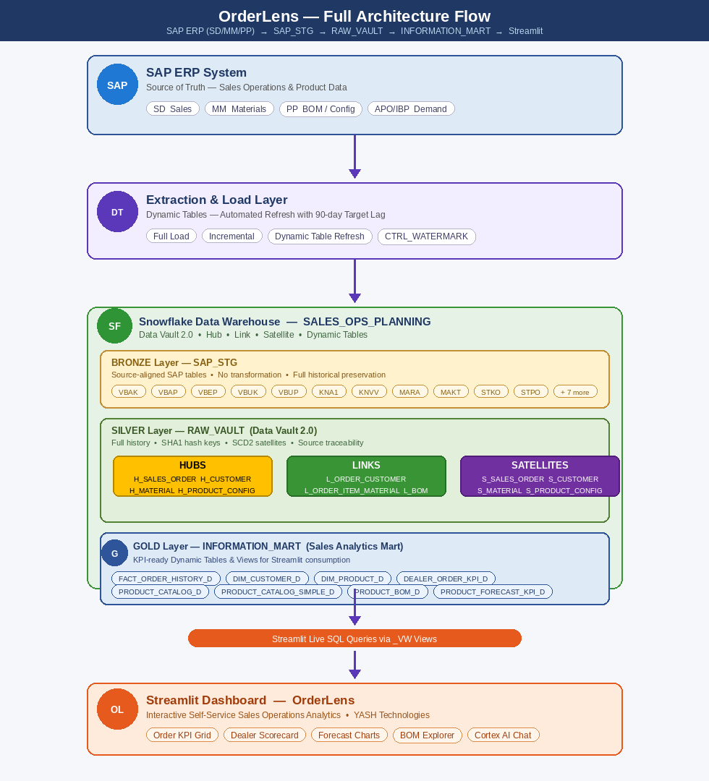

6. Data Pipeline Source / Target Details
Environment | Source System | Source Server | Snowflake Warehouse | Schema
DEV | SAP DEV | <SAP-DEV-SID> — To be confirmed | WH_ORDERLENS_DEV | SALES_DEV
UAT | SAP UAT | <SAP-UAT-SID> — To be confirmed | WH_ORDERLENS_UAT | SALES_UAT
PROD | SAP PROD | <SAP-PROD-SID> — To be confirmed | WH_ORDERLENS_PROD | SALES_PROD

Note: SAP System IDs (SIDs) are placeholders and must be confirmed with the SAP Basis team before this document is finalized for stakeholder distribution. The Snowflake database is SALES_OPS_PLANNING across all environments. Schemas SAP_STG, RAW_VAULT, and INFORMATION_MART are shared across DEV, UAT, and PROD via environment-prefixed warehouse assignments.

7. Data Architecture & Processing Layers
The OrderLens platform follows a three-layer Warehouse architecture implemented on Snowflake (database: SALES_OPS_PLANNING) using Data Vault 2.0 modelling. Data is progressively refined across Bronze (SAP_STG), Silver (RAW_VAULT), and Gold (INFORMATION_MART) layers to ensure scalability, governance, and analytical readiness.

7.1 Bronze Layer — SAP_STG (SAP Source-Aligned)
The Bronze layer is the landing zone for all data ingested from SAP ERP. This layer preserves the original structure and historical state of SAP source data, ensuring full traceability, auditability, and the ability to replay loads. All 19 SAP staging tables reside in the SAP_STG schema of SALES_OPS_PLANNING.

SAP Source Tables Ingested:
SAP Table | Description | SAP Module
SAP_VBAK | Sales Order Header — order date, sales org, distribution channel, division, customer, currency, net value | SD
SAP_VBAP | Sales Order Items — material, order quantity, UoM, unit price (NETPR), net item value, plant, item category | SD
SAP_VBEP | Schedule Lines — confirmed quantity, open quantity, promised delivery date per order item | SD
SAP_VBUK | Sales Document Header Status — overall status (GBSTK), delivery status (LFGSK), billing status (FKSAA) | SD
SAP_VBUP | Sales Document Item Status — per-item overall, delivery, and billing status codes | SD
SAP_KNA1 | Customer Master General Data — name, country, region, city, postal code, classification (KUKLA), account group | SD
SAP_KNVV | Customer Sales Area Data — customer group (KDGRP), sales district (BZIRK), ABC class (KLABC), incoterms | SD
SAP_MARA | Material Master General Data — material type, group, product hierarchy, external group, base UoM | MM
SAP_MAKT | Material Descriptions — language-keyed material text; English (SPRAS='EN') filtered for MATERIAL_NAME | MM
SAP_MVKE | Material Sales Data — sales org / channel, material groups MVGR1/MVGR2, product hierarchy PRODH | MM / SD
SAP_MARC | Plant-Specific Material Data — MRP controller (DISPO), procurement type (BESKZ) per plant | MM
SAP_T001W | Plant / Branch Master Data — plant name, region, country | MM
SAP_STKO | BOM Header — BOM number, category, alternative, valid-from date, base quantity, parent material, plant | PP
SAP_STPO | BOM Items — component material (IDNRK), component quantity (MENGE), UoM, scrap factor (AUSCH), sort string | PP
SAP_PRODUCT_CONFIG | Product Configuration Master — config ID, name, type, status, default flag, base price, additional cost, total price | CPQ / SD
SAP_PRODUCT_FEATURE | Product Feature Assignments — feature code, feature name, product ID, config ID | CPQ / SD
SAP_PRODUCT_FORECAST | Legacy Forecast Staging — product, period end, forecast quantity and revenue (superseded by SAP_DEMAND_PLAN) | APO
SAP_DEMAND_PLAN | Demand Planning Input — product, period end, demand quantity, demand revenue, demand source for 6-month forward blending | APO / IBP

Key Activities:
- Ingestion of full and incremental data from SAP SD, MM, PP, and APO / IBP modules
- Addition of technical metadata: LOAD_DT (ingestion timestamp) and SOURCE_SYSTEM identifier
- Schema preservation with minimal transformations — original SAP column names retained
- Historical versioning using Snowflake time-travel on all SAP_STG tables
- Storage of raw data for replay and recovery — no business rules applied at this layer

Note: No business rules or complex transformations are applied in the Bronze layer. The ingested data is preserved exclusively for downstream transformation processing.

Load Type | Approach | Technology
Full Load (Initial) | Complete historical extraction from all 19 SAP source tables | Snowflake Stored Procedures / COPY INTO
Incremental Load | Scheduled extraction using LAST_CHANGED_AT watermark column | Snowflake Dynamic Tables — 90-day target lag (REFRESH_MODE = AUTO)

Naming Conventions:
Component | Naming Convention
Staging Table | SAP_STG.SAP_<SAP_TABLE_NAME> (e.g. SAP_STG.SAP_VBAK)
Ingestion Timestamp | LOAD_DT TIMESTAMP_NTZ — present on all SAP_STG tables
Source System Column | SOURCE_SYSTEM STRING = 'SAP_STG' (on SAP_VBAK only; metadata standard)
Full Load SP | sp_<env>_OrderLens_full_load_master
Incremental Load SP | sp_<env>_OrderLens_incremental_master
Ingestion Log Table | CTRL_INGESTION_LOG
Watermark Control Table | CTRL_WATERMARK

7.2 Silver Layer — RAW_VAULT (Data Vault 2.0)
The Silver layer implements Data Vault 2.0 modelling in Snowflake. This layer transforms raw source data into business-aligned vault structures — Hubs, Links, and Satellites — while maintaining full historical traceability and auditability. All objects reside in the RAW_VAULT schema of SALES_OPS_PLANNING.

Key Activities:
- Data cleansing, standardization, and type correction from SAP_STG staging tables
- Hash key generation: SHA1_HEX for Hub keys; SHA1_HEX(CONCAT_WS('|',...)) for composite keys; MD5 for HASHDIFF
- Deduplication and key resolution across SAP sales entities (VBELN, KUNNR, MATNR, CONFIG_ID)
- SCD Type 2 history tracking on all Satellites via LOAD_DT / END_DT / HASHDIFF columns
- Business rule application: status code mapping (GBSTK/LFGSK), customer join (KNA1 + KNVV on KUNNR), material enrichment (MARA + MAKT + MVKE)
- Automated refresh via Snowflake Dynamic Tables with 90-day target lag on CORTEX_ANALYST_WH

7.2.1 Hub Tables
Hubs represent the core business entities — each Hub stores a unique business key with a hash key and load metadata. Hubs are the backbone of the Data Vault 2.0 model. OrderLens implements 6 Hub tables covering all key sales domain entities.

Hub Table | Business Key | Source SAP Table | Description
H_SALES_ORDER | SALES_ORDER_ID (VBELN) | SAP_VBAK | Sales order header entity identities. Hash: SHA1_HEX(UPPER(TRIM(VBELN)))
H_SALES_ORDER_ITEM | SALES_ORDER_ID + SALES_ORDER_ITEM_ID | SAP_VBAP | Sales order line item identities. Hash: SHA1_HEX(CONCAT_WS('|',VBELN,POSNR))
H_CUSTOMER | CUSTOMER_ID (KUNNR) | SAP_KNA1 | Customer / sold-to account entity identities
H_MATERIAL | MATERIAL_ID (MATNR) | SAP_MARA | Material / product entity identities
H_PRODUCT_CONFIG | CONFIG_ID | SAP_PRODUCT_CONFIG | Product configuration entity identities
H_FEATURE | FEATURE_CODE | SAP_PRODUCT_FEATURE | Product feature entity identities

Hub Table Standard Structure:
H_<ENTITY>
─────────────────────────────────────────────────────────────
<ENTITY>_HK VARCHAR(40) (Hash Key — PK, SHA1_HEX of business key)
<ENTITY>_BK VARCHAR (Business Key, e.g. SALES_ORDER_ID = VBELN)
LOAD_DT TIMESTAMP_NTZ
RECORD_SOURCE VARCHAR

7.2.2 Link Tables
Links represent relationships between two or more Hubs. Each Link stores the foreign hash keys of the related Hubs, capturing the association with full historical integrity. OrderLens implements 6 Link tables covering all key sales domain relationships.

Link Table | Connected Hubs | Source SAP Tables | Description
L_ORDER_CUSTOMER | H_SALES_ORDER + H_CUSTOMER | SAP_VBAK | Sales order ↔ sold-to customer relationship (VBELN ↔ KUNNR)
L_ORDER_ITEM | H_SALES_ORDER + H_SALES_ORDER_ITEM | SAP_VBAP | Sales order ↔ order line item relationship
L_ORDER_ITEM_MATERIAL | H_SALES_ORDER_ITEM + H_MATERIAL | SAP_VBAP | Order item ↔ ordered material relationship (MATNR)
L_ORDER_ITEM_CONFIG | H_SALES_ORDER_ITEM + H_PRODUCT_CONFIG | SAP_VBAP + SAP_PRODUCT_CONFIG | Order item ↔ configuration linkage (joined on PRODUCT_ID = MATNR)
L_CONFIG_FEATURE | H_PRODUCT_CONFIG + H_FEATURE | SAP_PRODUCT_FEATURE | Configuration ↔ feature assignment linkage
L_BOM | H_MATERIAL (parent) + H_MATERIAL (child) | SAP_STKO / SAP_STPO | Parent material ↔ child component BOM linkage

Link Table Standard Structure:
L_<ENTITY_A>_<ENTITY_B>
──────────────────────────────────────────────────────
<EA>_HK VARCHAR(40) (FK to Hub A)
<EB>_HK VARCHAR(40) (FK to Hub B)
LOAD_DT TIMESTAMP_NTZ
RECORD_SOURCE VARCHAR

7.2.3 Satellite Tables
Satellites store all descriptive, context, and changing attributes for their parent Hubs or Links. Each satellite record is date-stamped via LOAD_DT, providing a full SCD2 history of attribute changes over time. OrderLens implements 10 Satellite tables.

Satellite Table | Parent Hub / Link | Source SAP Tables | Description
S_SALES_ORDER | H_SALES_ORDER | SAP_VBAK | Order attributes — date, sales org, distribution channel, division, currency, net value, order type
S_SALES_ORDER_ITEM | H_SALES_ORDER_ITEM | SAP_VBAP | Item attributes — product ID, quantity ordered, unit price (NETPR), item net value, plant, UoM
S_ORDER_STATUS | H_SALES_ORDER | SAP_VBUK / SAP_VBUP | Header and item status attributes — overall, delivery, and billing status codes
S_SCHEDULE_LINE | H_SALES_ORDER_ITEM | SAP_VBEP | Schedule line attributes — promised delivery date (EDATU), confirmed quantity (BMENG), open quantity (WMENG)
S_CUSTOMER | H_CUSTOMER | SAP_KNA1 + SAP_KNVV | Customer attributes — name, country, region, city, classification (KUKLA), ABC class (KLABC), incoterms, sales district
S_MATERIAL | H_MATERIAL | SAP_MARA + SAP_MAKT + SAP_MVKE | Material attributes — name, type, group, hierarchy, external group, UoM, product type, category, family
S_PRODUCT_CONFIG | H_PRODUCT_CONFIG | SAP_PRODUCT_CONFIG | Configuration attributes — name, type, status, default flag, base price, additional cost, total price
S_FEATURE | H_FEATURE | SAP_PRODUCT_FEATURE | Feature attributes — feature code and feature name
S_BOM_COMPONENT | L_BOM (parent+child) | SAP_STPO | BOM component attributes — quantity per assembly, UoM, scrap factor, component sequence, criticality flag
S_PRODUCT_FORECAST | H_MATERIAL | SAP_PRODUCT_FORECAST | Legacy forecast satellite — forecast quantity and revenue per period (superseded by demand plan blending)

Satellite Table Standard Structure:
S_<ENTITY>
──────────────────────────────────────────────────────────────
HUB/LINK_<ENTITY>_HK VARCHAR(40) (Parent Hash Key)
LOAD_DT TIMESTAMP_NTZ (Record effective date)
END_DT TIMESTAMP_NTZ (Expiry date — NULL for current record)
RECORD_SOURCE VARCHAR
HASHDIFF STRING (MD5 of all descriptive columns — change detection)
<descriptive columns> ...

Data Vault Naming Conventions:
Component | Naming Convention
Hub Table | H_<ENTITY_NAME> (e.g. H_SALES_ORDER, H_CUSTOMER)
Link Table | L_<ENTITY_A>_<ENTITY_B> (e.g. L_ORDER_CUSTOMER)
Satellite Table | S_<ENTITY_OR_CONTEXT> (e.g. S_SALES_ORDER, S_CUSTOMER)
Hub Hash Key | SHA1_HEX(UPPER(TRIM(COALESCE(<business_key>,''))))
Composite Hash Key | SHA1_HEX(CONCAT_WS('|', key1, key2)) e.g. VBELN|POSNR
HASHDIFF | MD5 of all descriptive satellite columns concatenated
Dynamic Table (Mart) | <OBJECT_NAME>_D (e.g. DIM_CUSTOMER_D, FACT_ORDER_HISTORY_D)
View (Mart) | <OBJECT_NAME>_VW (SELECT * pass-through on _D table)

7.3 Gold Layer — INFORMATION_MART (Sales Analytics Mart)
The Gold layer represents the curated, business-ready data optimized for reporting, dashboards, and advanced analytics. All objects are implemented as Snowflake Dynamic Tables with a 90-day target lag (_D suffix) and exposed via lightweight SELECT * views (_VW suffix) for application and model consumption. The mart resides in the INFORMATION_MART schema of SALES_OPS_PLANNING.

Sales Analytics Mart — KPI Fact Metrics:
KPI Metric | Formula / Source | Description
Total Revenue | SUM(TOTAL_AMOUNT) WHERE CURRENT_FLAG='Y' | Total order revenue across all products and configurations in selected period
On-Time Delivery Rate | (Delivered on/before EXPECTED_DELIVERY_DATE / Total) × 100 | % of orders delivered on or before the promised schedule line date
Avg Order Value | SUM(TOTAL_AMOUNT) / COUNT(DISTINCT ORDER_ID) | Average revenue per sales order
Dealer Revenue Share | SUM(revenue by DEALER_ID) / Total Revenue × 100 | % of total revenue contributed by each dealer
Config Mix % | COUNT(orders by CONFIG_NAME) / Total Orders × 100 | Split of orders across Base / Standard / Premium configurations
Forecast Quantity | 0.6 × DEMAND_QUANTITY + 0.4 × ROLLING_3MO_QTY | Blended 6-month forward quantity forecast per product
Order Pipeline Value | SUM(TOTAL_AMOUNT) WHERE ORDER_STATUS IN ('PLACED','CONFIRMED') | Value of open orders not yet shipped or delivered
BOM Effective Quantity | QUANTITY_PER_ASSEMBLY × (1 + SCRAP_FACTOR) | Net component quantity required accounting for expected scrap

Gold Layer Dynamic Tables & Views:
Table / View | Type | Description
DIM_CUSTOMER_D / _VW | SCD Type 2 | Customer dimension with full history — name, country, region, ABC class, incoterms, 15 columns
DIM_PRODUCT_D / _VW | SCD Type 2 | Product dimension with full history — type, group, hierarchy, category, family, 14 columns
DIM_DEALER_D / _VW | SCD Type 2 | Dealer dimension (ABC-classified customer subset) with dealer type derivation (Premium/Standard/Associate)
DIM_FEATURE_D / _VW | SCD Type 2 | Feature dimension for product configuration features
FACT_ORDER_HISTORY_D / _VW | Fact Table | Order history fact with full status progression (PLACED → CONFIRMED → SHIPPED → DELIVERED), 21 columns
DEALER_ORDER_KPI_D / _VW | Aggregate Fact | Daily dealer × product × config KPI rollup — order count, quantity ordered, revenue
PRODUCT_CATALOG_D / _VW | Reference | Full product × configuration catalog with pricing — Base / Standard / Premium configs and UNIT_PRICE
PRODUCT_CATALOG_SIMPLE_D / _VW | Reference | Simplified product listing without configuration details — one row per product
PRODUCT_BOM_D / _VW | Reference | Bill of materials — parent/child product relationships, quantities per assembly, scrap factors
PRODUCT_FORECAST_KPI_D / _VW | Forecast Fact | 6-month forward forecast blending rolling 3-month sales average and demand plan (60/40 weighted)

Information Mart Build Pipeline Activities:
Step | Activity | Description
1 | Build Dimension Tables | Create SCD Type 2 Dynamic Tables: DIM_CUSTOMER_D, DIM_PRODUCT_D, DIM_DEALER_D, DIM_FEATURE_D using LEAD() window function for EXPIRY_DATE
2 | Build Fact Table | Create FACT_ORDER_HISTORY_D joining all Hubs, Links, and latest Satellites; derive PLACED → CONFIRMED → SHIPPED → DELIVERED status progression via STATUS_LEVEL CTE
3 | Build KPI Aggregates | Create DEALER_ORDER_KPI_D — DATE_TRUNC('DAY') × DEALER × PRODUCT × CONFIG aggregation of ORDER_COUNT, QUANTITY_ORDERED, REVENUE from FACT_ORDER_HISTORY_D WHERE CURRENT_FLAG='Y'
4 | Build Product Catalog | Create PRODUCT_CATALOG_D (full with config × pricing) and PRODUCT_CATALOG_SIMPLE_D (product-only, one row per product) from DIM_PRODUCT_D
5 | Build BOM View | Create PRODUCT_BOM_D resolving parent / child MATERIAL_ID and PRODUCT_NAME from DIM_PRODUCT_D via L_BOM and H_MATERIAL
6 | Build Forecast KPI | Create PRODUCT_FORECAST_KPI_D: 24-month rolling sales → 3MO average → cross-join 6 forward months → blend with SAP_DEMAND_PLAN (60% demand + 40% rolling)
7 | Expose via Views | Create all _VW views (SELECT * pass-through) on every _D Dynamic Table. App and Cortex model.yml reference _VW objects only

8. Dealer Health & Scorecard
This section describes the Dealer Health architecture as implemented in the OrderLens platform. Dealer health is evaluated through three interconnected pages — Sales Health Landing, Dealer Health Scorecard, and Sales KPI Grid — all powered by real-time Snowflake queries against the INFORMATION_MART Gold Layer views.

Sales Health Landing Page:
The landing page provides end-to-end visibility across the full sales order lifecycle. It includes:
- Global Filters: Date Range, Dealer, Product Category, Configuration Type, Order Status, Sales District, Region — applied across all metrics
- Order Journey Overview: Visual representation of the sales lifecycle — Order Placement → Confirmation → Shipment → Delivery
- Strategic Insights Panel: AI-generated insights such as Order Backlog exposure, Dealer Concentration risk, Configuration Mix trends, and Forecast vs Actual variance signals

Dealer Health Scorecard:
The Scorecard evaluates each dealer across 8 key performance categories and assigns a score on a 1–7 scale with a corresponding rating band.

Score Rating Bands:
Score | Rating
1 – 2 | Critical
3 – 4 | Average
5 | Good
6 – 7 | Excellent

Dealer Health Scorecard — Performance Categories:
Performance Category | KPI | Score | Rating
Order Volume | Total Order Count | 6 / 7 | Excellent
Revenue Contribution | Total Revenue | 7 / 7 | Excellent
Config Adoption | Premium Config Mix % | 4 / 7 | Average
Delivery Performance | On-Time Delivery Rate | 5 / 7 | Good
Order Backlog | Open Order Pipeline Value | 6 / 7 | Excellent
Avg Order Value | Revenue per Order | 5 / 7 | Good
Forecast Alignment | Forecast vs Actual Variance % | 4 / 7 | Average
Dealer Concentration | Top-5 Dealer Revenue Share % | 5 / 7 | Good
Overall Health | Average of all 8 categories | 5.25 / 7 | Good

Scoring Computation Logic:
- Each KPI value is fetched from DEALER_ORDER_KPI_VW / FACT_ORDER_HISTORY_VW in real time
- Score is computed per category using configurable threshold rules stored in a Snowflake control table
- Overall Health Score = Average of all 8 category scores
- Rating band is assigned dynamically based on score range (1–2 Critical, 3–4 Average, 5 Good, 6–7 Excellent)
- Dealer type classification (Premium / Standard / Associate) is derived from ABC_CLASS in DIM_DEALER_D: A → Premium, B → Standard, else → Associate

9. Dashboard Architecture (Streamlit)
The Streamlit dashboard connects directly to Snowflake's Gold Layer (INFORMATION_MART) and renders sales order KPIs, dealer performance metrics, product catalog, BOM analysis, and demand forecasting in real time. All queries are executed against the _VW views for abstraction from underlying Dynamic Table names.

Dashboard Components:
Component | Type | Description
KPI Grid | Metric Cards | Top-row tiles: Total Orders, Total Revenue, On-Time Delivery %, Avg Order Value, Open Pipeline Value
View Toggle | Radio Button | Switch between Dealer, Product, Configuration, and Region views across all visuals
Date Range Filter | Date Picker | User-selected start / end date applied to all queries via EFFECTIVE_DATE column
Dealer Filter | Multi-Select | Filter by specific dealer(s) from DIM_DEALER_VW
Product Filter | Multi-Select | Filter by product category or family from PRODUCT_CATALOG_SIMPLE_VW
Config Filter | Dropdown | Filter by configuration type (STANDARD / CUSTOM) or name (Base / Standard / Premium)
Order Status Filter | Multi-Select | Filter by ORDER_STATUS (PLACED / CONFIRMED / SHIPPED / DELIVERED) from FACT_ORDER_HISTORY_VW
Dealer Health Chart | Pie / Donut | Visual breakdown of dealers by health rating band (Critical / Average / Good / Excellent)
Revenue Trend Chart | Line / Bar Chart | Revenue trend over selected period by dealer, product, or configuration from DEALER_ORDER_KPI_VW
Dealer Performance Grid | Data Grid | Sortable dealer KPI table with order count, quantity, revenue, and computed health score
Product Catalog View | Data Grid | Product × config pricing table from PRODUCT_CATALOG_VW showing Base / Standard / Premium UNIT_PRICE
BOM Explorer | Tree / Grid | Parent-child BOM hierarchy with quantities per assembly and scrap factors from PRODUCT_BOM_VW
Forecast vs Actual | Combo Chart | 6-month forward forecast vs actual sales per product from PRODUCT_FORECAST_KPI_VW
AI Insights Section | Text Panel | Cortex / OpenAI generated natural language insights on order trends, dealer risks, and forecast anomalies

UI Design Specifications:
Property | Value
Primary Color Theme | Midnight Blue (#1F3864) + Accent Blue (#2E75B6)
Background | White / Light Gray (#F9F9F9)
Layout | Responsive, 5-column KPI grid at top, tabbed navigation for sub-pages
Font | Arial / Calibri
Chart Library | Plotly (via Streamlit)
Data Layer | All queries execute against INFORMATION_MART _VW views only
Rendering | Dynamic — re-renders on every filter change via live Snowflake SQL

10. Cortex / AI Integration
The OrderLens platform can optionally leverage Snowflake Cortex (recommended — fully in-platform, no external API required) to provide AI-driven insights, natural language querying, and intelligent sales performance analysis.

AI Use Cases
- Natural Language Insights: Business users can ask questions in plain English about order volumes, revenue, dealer performance, and product demand
- Order Trend Explanation: AI summarizes drivers of revenue growth or decline by product, configuration, or dealer segment
- Dealer Risk Reasoning: AI identifies early dealer risk signals, concentration exposure, and declining order velocity
- Demand Forecast Reasoning: AI explains forecast adjustments based on demand plan vs sales velocity signal weighting (60/40)
- Anomaly Detection: Detect unusual spikes or drops in order volumes, pricing anomalies, or unexpected configuration mix shifts

AI Architecture Flow
Step | Component | Description
1 | User Query | User enters natural language question in Streamlit OrderLens dashboard
2 | Context Retrieval | Relevant order, dealer, and product data fetched from Gold Layer INFORMATION_MART _VW views
3 | AI Model Processing | Cortex COMPLETE processes structured sales data context and generates plain-language insight
4 | Response Rendering | AI-generated insight displayed in dashboard AI Insights panel alongside charts

Integration Architecture — Component Stack
Component | Technology
Frontend | Streamlit Dashboard (OrderLens)
Data Access | Snowflake SQL Endpoint via INFORMATION_MART _VW views
Primary Data Source | FACT_ORDER_HISTORY_VW / DEALER_ORDER_KPI_VW / PRODUCT_FORECAST_KPI_VW
AI Engine (Primary) | Snowflake Cortex AI — fully in-platform, no external API
AI Engine (Secondary) | Azure OpenAI — optional external integration
Query Processing | Natural language → SQL conversion via Cortex COMPLETE and Cortex Analyst

11. Security & Access Control

Snowflake RBAC
Role | Layer Access | Permissions
Data Engineer | All Layers | Full warehouse access — SAP_STG, RAW_VAULT, INFORMATION_MART schemas
BI Developer | RAW_VAULT + INFORMATION_MART | Read on analytics schemas; write to INFORMATION_MART Gold layer
Business User | Dashboard Only | Streamlit OrderLens dashboard access only; queries via _VW views
Service Role | Dynamic Tables | Dynamic Table execution on CORTEX_ANALYST_WH; no raw table direct access
Audit Role | SAP_STG Layer | Read-only access to Bronze SAP_STG layer for audit and compliance review
ML Engineer | RAW_VAULT + INFORMATION_MART | Read on Silver + Gold; Snowflake ML Functions and Cortex AI endpoints; no write to production
Sales Analyst | INFORMATION_MART | Read on Gold layer _VW views only; dashboard and self-service report access

Secrets & Credential Management
- Snowflake credentials stored in environment-based secret manager — no hardcoded passwords
- Environment-based configuration (DEV / UAT / PROD) with separate service accounts per environment
- Service account principle — minimum required privileges granted per role
- All API keys (Cortex / Azure OpenAI) managed via Snowflake Secrets or environment variables

12. Error Handling & Recovery
Component | Error Handling Mechanism | Recovery Approach
Dynamic Tables | Snowflake-managed retry on target lag failure; refresh history logged | Automatic re-materialization on next scheduled refresh cycle
SAP_STG Ingestion | Stored procedure try-catch blocks with error code capture | Re-run stored procedure from last successful LOAD_DT watermark
Snowflake Queries | Snowflake query history and CTRL_SP_EXECUTION_LOG table | SP error logging with notification; manual investigation via Query History
Streamlit App | Python exception handling with st.error() display | User-friendly error messages displayed; query retry on refresh
Data Quality | DQ check results logged to CTRL_DQ_LOG control table | Reject records quarantined in error table; downstream tables not blocked

13. Logging & Monitoring
Monitoring Overview:
Component | Monitoring Tool | What is Monitored
Snowflake Warehouse | Snowflake Query History | Query execution time, credit cost, failures
Dynamic Tables | Dynamic Table Refresh History | Refresh lag, row counts, materialization duration, failures
Stored Procedures | CTRL_SP_EXECUTION_LOG | SP run status, row counts inserted, duration
Watermark Control | CTRL_WATERMARK table | Last successful LOAD_DT per source table
Streamlit App | Application Logs | User session logs, query failures, filter usage patterns
Data Quality | CTRL_DQ_LOG table | Rejected records, null hash key violations, quality check failures

Logging Infrastructure:
- CTRL_SP_EXECUTION_LOG — records stored procedure execution metadata (SP name, run status, row count, start/end timestamp)
- CTRL_WATERMARK — tracks incremental load watermarks (last successful LOAD_DT) per source SAP_STG table
- CTRL_DQ_LOG — records data quality check results, rejected record counts, and check failure reasons
- CTRL_INGESTION_LOG — records row counts and load timings per ingestion cycle for capacity planning

14. Testing Strategy
The testing strategy covers all layers of the OrderLens platform — from stored procedure unit tests through to business user acceptance. Tests are executed in DEV first, then promoted to UAT for stakeholder sign-off before any PROD deployment. The Data Engineering team is responsible for Unit, Integration, and Data Vault Integrity tests. The BI team is responsible for Data Validation and Performance tests. Business stakeholders are responsible for UAT sign-off. All test results must be documented and sign-off obtained before promotion to the next environment.

Test Type | Scope | Approach
Unit Testing | Individual stored procedures and Dynamic Tables | Test each object with controlled SAP_STG input data; validate row counts and hash key generation
Integration Testing | SAP → Snowflake → Dashboard | End-to-end pipeline validation across all three layers (SAP_STG → RAW_VAULT → INFORMATION_MART)
Data Validation | KPI reconciliation | Compare dashboard KPIs vs SAP SD source order totals, item counts, and revenue figures
Data Vault Integrity | Hub / Link / Satellite joins | Validate SHA1 hash key consistency, record counts, SCD2 LOAD_DT/END_DT record chains, and HASHDIFF change detection
Order Status Validation | FACT_ORDER_HISTORY status progression | Verify PLACED → CONFIRMED → SHIPPED → DELIVERED STATUS_LEVEL logic, EFFECTIVE_DATE derivation, and CURRENT_FLAG accuracy
Performance Testing | Dashboard query SLA | Target query response < 3 seconds against _VW views on CORTEX_ANALYST_WH
Forecast Validation | PRODUCT_FORECAST_KPI_D accuracy | Validate 60/40 blending logic, 3-month rolling average calculation, and 6-month forward period GENERATOR output
UAT | Business user acceptance | Sales operations and product management stakeholders validate KPI accuracy against known SAP source data

15. Deployment Strategy
DEV → UAT → PROD
Environment | Purpose | Promotion Condition
DEV | Development and unit testing | All unit tests pass; peer code review complete
UAT | User acceptance testing | Business UAT sign-off; data validation passed
PROD | Live production environment | UAT approved; change management ticket raised

- All code (Dynamic Table DDL, Stored Procedures, Streamlit app, migration scripts) stored in Git version control
- Snowflake objects deployed via numbered migration scripts — no manual direct modification of any environment
- No direct PROD object modification — all changes promoted through DEV → UAT → PROD pipeline
- Rollback plan documented for each release; Dynamic Table DDL versioned via Schemachange or Flyway

Snowflake Object Versioning: Snowflake DDL scripts (CREATE TABLE, CREATE DYNAMIC TABLE, CREATE VIEW, Stored Procedures) are versioned using a migration-based approach. The recommended tooling is Schemachange (open-source, Snowflake-native) or Flyway. Each migration script is numbered sequentially and executed in order per environment. Scripts are never modified after execution — corrections are applied as new versioned migration scripts. This ensures full auditability of all schema changes across DEV, UAT, and PROD environments.

16. Data Retention Policy
Layer | Tables | Retention Period
Bronze — SAP_STG | All 19 SAP SD / MM / PP / APO source-aligned staging tables | 7 Years
Silver — RAW_VAULT | All 6 Hubs, 6 Links, 10 Satellites (full SCD2 history preserved) | 7 Years
Gold — INFORMATION_MART | All 10 Dynamic Tables (_D) and 9 Views (_VW) in INFORMATION_MART schema | 5 Years
Control / Log Tables | CTRL_WATERMARK — Permanent (critical for incremental recovery); CTRL_SP_LOG, CTRL_DQ_LOG — 90 Days | Permanent / 90 Days
Dashboard Logs | Streamlit OrderLens application session and query logs | 90 Days

17. Key KPIs Implemented
KPI Name | Formula | Source View | Category
Total Orders | COUNT(DISTINCT ORDER_ID) WHERE CURRENT_FLAG='Y' | FACT_ORDER_HISTORY_VW | Order Analytics
Total Revenue | SUM(TOTAL_AMOUNT) WHERE CURRENT_FLAG='Y' | FACT_ORDER_HISTORY_VW | Order Analytics
Revenue by Product | SUM(TOTAL_AMOUNT) GROUP BY PRODUCT_ID | FACT_ORDER_HISTORY_VW | Order Analytics
Revenue by Dealer | SUM(TOTAL_AMOUNT) GROUP BY DEALER_ID | DEALER_ORDER_KPI_VW | Order Analytics
Revenue by Config | SUM(TOTAL_AMOUNT) GROUP BY CONFIG_NAME | DEALER_ORDER_KPI_VW | Order Analytics
Avg Order Value | SUM(TOTAL_AMOUNT) / COUNT(DISTINCT ORDER_ID) | FACT_ORDER_HISTORY_VW | Order Analytics
Open Pipeline Value | SUM(TOTAL_AMOUNT) WHERE ORDER_STATUS IN ('PLACED','CONFIRMED') | FACT_ORDER_HISTORY_VW | Pipeline
Backlog Order Count | COUNT(DISTINCT ORDER_ID) WHERE STATUS IN ('PLACED','CONFIRMED') | FACT_ORDER_HISTORY_VW | Pipeline
On-Time Delivery Rate | (Delivered on/before EXPECTED_DELIVERY_DATE / Total) × 100 | FACT_ORDER_HISTORY_VW | Delivery
Avg Days to Deliver | AVG(DATEDIFF(DELIVERY_DATE, ORDER_STATUS_DATE)) WHERE DELIVERED | FACT_ORDER_HISTORY_VW | Delivery
Config Mix % | COUNT by CONFIG_NAME / Total Orders × 100 | DEALER_ORDER_KPI_VW | Product
Premium Config Rate | COUNT(CONFIG_NAME='Premium') / Total Orders × 100 | DEALER_ORDER_KPI_VW | Product
Catalog Unit Price | TOTAL_PRICE from S_PRODUCT_CONFIG (latest record) | PRODUCT_CATALOG_VW | Pricing
Active Dealers | COUNT(DISTINCT DEALER_ID) WHERE ORDER_COUNT > 0 | DEALER_ORDER_KPI_VW | Dealer Intelligence
Dealer Health Rating % | (Rating Band Count / Total Dealers) × 100 | DEALER_ORDER_KPI_VW | Dealer Intelligence
Top-5 Dealer Revenue Share | (Top-5 Dealer Revenue / Total Revenue) × 100 | DEALER_ORDER_KPI_VW | Dealer Intelligence
BOM Effective Quantity | QUANTITY_PER_ASSEMBLY × (1 + SCRAP_FACTOR) | PRODUCT_BOM_VW | Manufacturing
Forecast Quantity | 0.6 × DEMAND_QUANTITY + 0.4 × ROLLING_3MO_QTY | PRODUCT_FORECAST_KPI_VW | Forecasting
Forecast Revenue | 0.6 × DEMAND_REVENUE + 0.4 × ROLLING_3MO_REVENUE | PRODUCT_FORECAST_KPI_VW | Forecasting

— End of Document —
YASH Technologies Pvt. Ltd. | OrderLens | Confidential

